**Day2**  
  
Nandha_FDP_Python_day 2_Sorting Searching Strings

Question 2

Reference image :

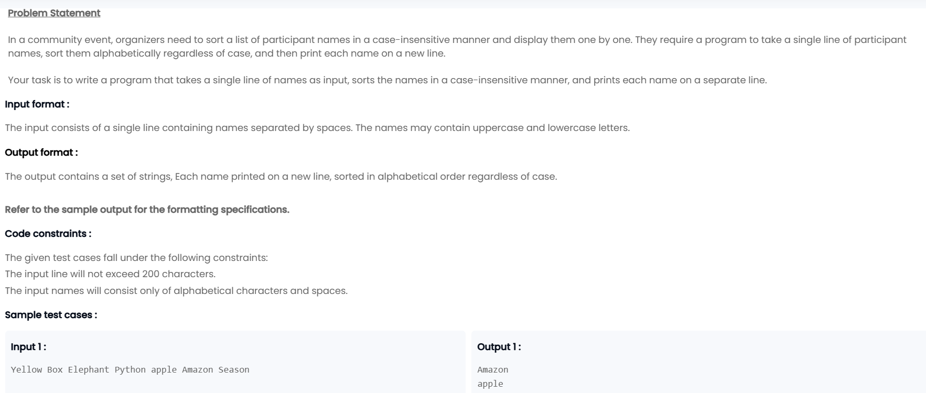

Day3

**FDP_Trainer Course_Python**

**Question3**

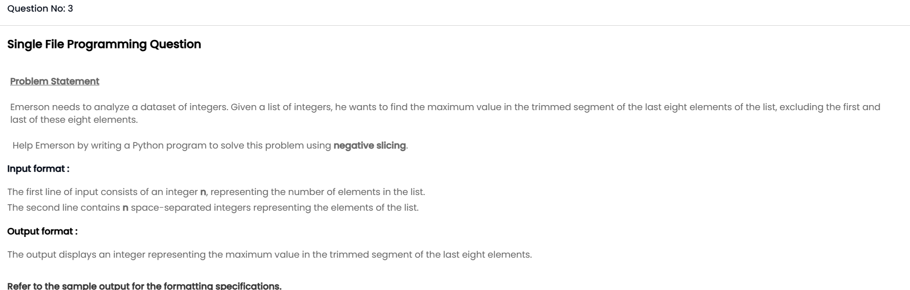

Day 4:

**Nandha_FDP_Python_day 4_Files**

**Question 4**

